LAB-6

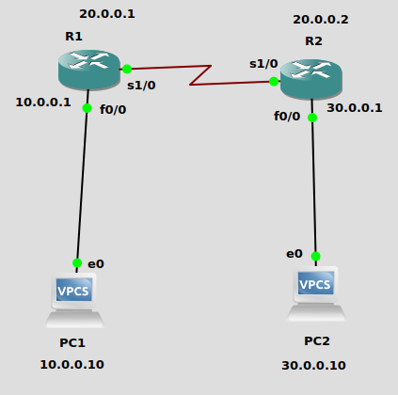
1.

Now both routers know all the networks.
i. Issue a ping command from PC1 to PC2, Router1 and PC4, respectively

Ans – From PC1 to PC2 -
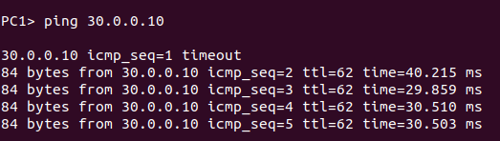
From PC2 to PC1 -

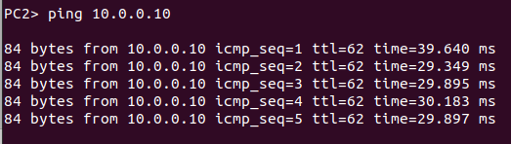
From PC1 to R1 -
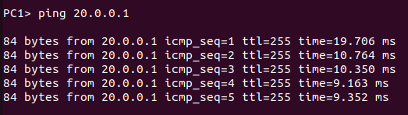
From PC1 to R2-
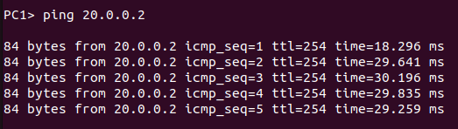
From PC2 to R1-
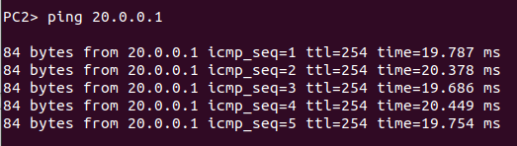
From PC2 to R2-
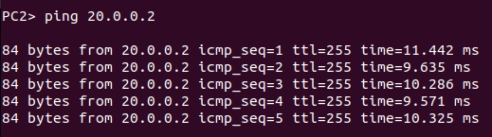

ii. Save the captured Wireshark output.
iii. Use the saved data to answer the following questions:
• What is the output on PC1 when the ping commands are issued?

Ans -
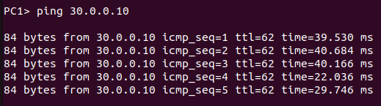

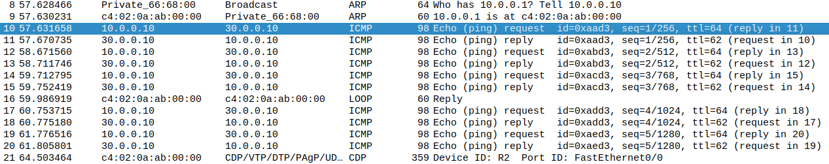
When a ping command from PC1 to PC2 is issued , first an ARP packet was sent to the router for determining the mac address of R1(10.0.0.1). Then ICMP requsts were sent from PC1 and requests were received through the router.

• Which packets, if any, are captured by Wireshark?

Ans- ARP,ICMP requests, ICMP replies and CDP packets were captured by wireshark.

• Do you observe any ARP packets? If so, what do they indicate?

Ans – Yes ARP packets were observed in the output. They indicated that PC1 is requesting the mac address of the router R1.

2. In the CSE department, two students sitting in two different labs want to establish a
connection and send the data. So, configure the below network topology as shown in Figure.
6.8 and check the connectivity by pinging from PC0 to PC2.

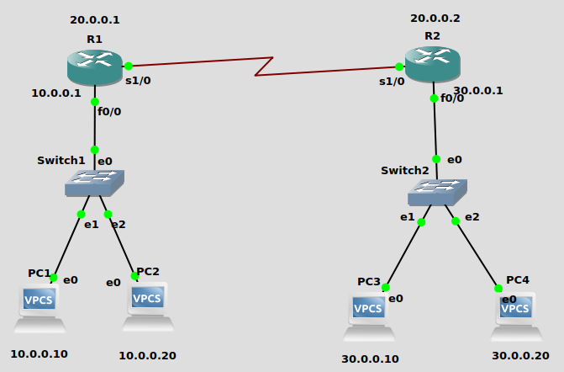

Configuration commands -

In R1-

R1#conf t
R1(config)#inter f0/0
R1(config-if)#ip address 10.0.0.1 255.0.0.0
R1(config-if)#no shutdown
R1(config-if)#exit
R1(config)#inter s1/0
R1(config-if)#ip address 20.0.0.1 255.0.0.0
R1(config-if)#clock rate 64000
R1(config-if)#encapsulation ppp
R1(config-if)#no shutdown
R1(config-if)#exit
R1(config)#ip route 30.0.0.0 255.0.0.0 20.0.0.2

in R2 -

R2(config)#inter f0/0
R2(config-if)#ip address 30.0.0.1 255.0.0.0
R2(config-if)#no shutdown
R2(config-if)#exit
R2(config)#inter s1/0
R2(config-if)#ip address 20.0.0.2 255.0.0.0
R2(config-if)#encapsulation ppp
R2(config-if)#no shutdown
R2(config-if)#exit
R2(config)#ip route 10.0.0.0 255.0.0.0 20.0.0.1

in PC1-
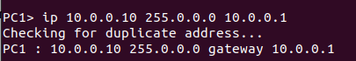

in PC2-
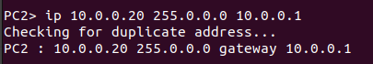

in PC3-
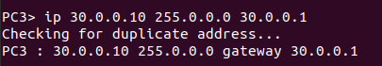

in PC4-
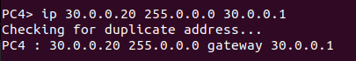

Now checking ping output from PC1 to PC3 -

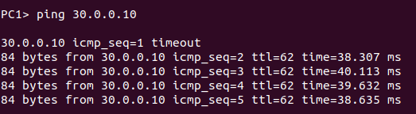
The network is working correctly. Now showing wireshark output.

